From: https://www.unz.com/pescobar/fauci-as-darth-vader-of-the-covid-wars/
Also at: https://www.zerohedge.com/covid-19/escobar-fauci-darth-vader-covid-wars
Also at: https://asiatimes.com/2021/11/fauci-as-darth-vader-of-the-covid-wars/
Fauci as Darth Vader of the Covid Wars
PEPE ESCOBAR • NOVEMBER 25, 2021
• 2,800 WORDS • 146 COMMENTS • REPLY
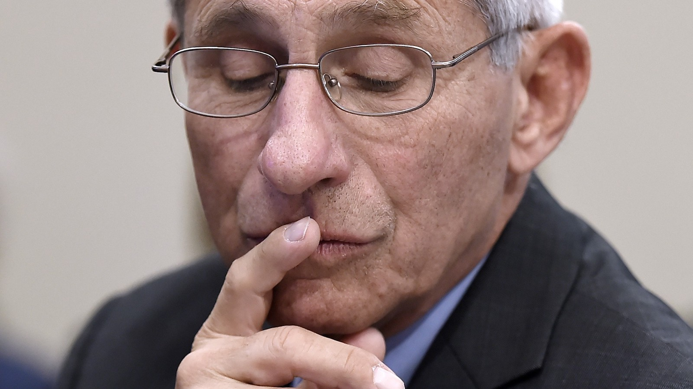
Robert F Kennedy Jr’s The Real Anthony Fauci: Bill Gates, Big Pharma and the Global War on Democracy and Public Health should be front-page news in all the news media in the US. Instead, it has been met with the proverbial thundering silence.
Critics seeking to have Kennedy dismissed as a kook trading on a famous name had scored a hit in February, when Instagram permanently deleted his account, allegedly for making false claims about coronavirus and vaccines. Nevertheless, the book, published only a few days ago, is already a certified pop hit on Amazon.
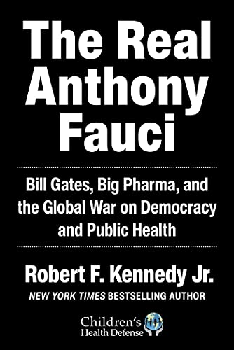
RFK Jr., chairman of the board of and chief legal counsel for Children’s Health Defense, sets out to deconstruct a New Normal, encroaching upon all of us since early 2020. In my early 2021 book Raging Twenties I have termed this force techno-feudalism.
Kennedy describes it as “rising totalitarianism,” complete with “mass propaganda and censorship, the orchestrated promotion of terror, the manipulation of science, the suppression of debate, the vilification of dissent and use of force to prevent protest.”
Focusing on Dr Anthony Fauci as the fulcrum of the biggest story of the 21st century allows RFK Jr to paint a complex canvas of planned militarization and, especially, monetization of medicine, a toxic process managed by Big Pharma, Big Tech and the military/intel complex – and dutifully promoted by mainstream media.
By now everyone knows that the big winners have been Big Finance, Big Pharma, Big Tech and Big Data, with a special niche for Silicon Valley behemoths.
Why Fauci? RFK Jr. argues that for five decades, he has been essentially a Big Pharma agent, nurturing “a complex web of financial entanglements among pharmaceutical companies and the National Institute of Allergy and Infectious Diseases (NIAID) and its employees that has transformed NIAID into a seamless subsidiary of the pharmaceutical industry. Fauci unabashedly promotes his sweetheart relationship with Pharma as a ‘public-private partnership.’”
Arguably the full contours of this very convoluted story have never before been examined along these lines, extensively documented and with a wealth of links. Fauci may not be a household name outside of the US and especially across the Global South. And yet it’s this global audience that should be particularly interested in his story.
RFK Jr accuses Fauci of having pursued nefarious strategies since the onset of Covid-19 – from falsifying science to suppressing and sabotaging competitive products that bring lower profit margins.
Kennedy’s verdict is stark: “Tony Fauci does not do public health; he is a businessman, who has used his office to enrich his pharmaceutical partners and expand the reach of influence that has made him the most powerful – and despotic – doctor in human history.”
This is a very serious accusation. It’s up to readers to examine the facts of the case and decide whether Fauci is some kind of medical Dr Strangelove.
No Vitamin D?
Pride of place goes to the Fauci-privileged modeling that overestimated Covid deaths by 525%, cooked up by fabricator Neil Ferguson of the Imperial College in London, duly funded by the Bill and Melinda Gates Foundation. This is the model, later debunked, that justified lockdown hysteria all across the planet.
Kennedy attributes to Canadian vaccine researcher Dr Jessica Rose the charge that Fauci was at the frontline of erasing the notion of natural immunity even as throughout 2020 the CDC and the World Health Organization (WHO) admitted that people with healthy immune systems bear minimal risk of dying from Covid.
Dr Pierre Kory, president of Front Line Covid-19 Critical Care Alliance, was among those who denounced Fauci’s modus operandi of privileging the development of tech vaccines while allowing no space for repurposed medications effective against Covid: “It is absolutely shocking that he recommended no outpatient care, not even Vitamin D.”
Clinical cardiologist Peter McCullough and his team of frontline doctors tested prophylactic protocols using, for instance, ivermectin – “we had terrific data from medical teams in Bangladesh” – and added other medications such as azithromycin, zinc, Vitamin D and IV Vitamin C. And all this while across Asia there was widespread use of saline nasal lavages.
By July 1, 2020, McCullough and his team submitted their first, ground-breaking protocol to the American Journal of Medicine. It became the most-downloaded paper in the world helping doctors to treat Covid-19.
McCullough complained last year that Fauci has never, to date, published anything on how to treat a Covid patient.” He additionally alleged: “Anyone who tries to publish a new treatment protocol will find themselves airtight blocked by the journals that are all under Fauci’s control.”
It got much worse. McCullough: “The whole medical establishment was trying to shut down early treatment and silence all the doctors who talked about success. A whole generation of doctors just stopped practicing medicine.” (A contrarian view would argue that McCullough got carried away: A million US doctors – the approximate number practicing at any given time – could not all have been in on it.)
The book argues that the reasons there was a lack of original research on how to fight Covid were the dependence of much-vaunted American academics on the billions of dollars granted by the National Institute of Health (NIH) and the fact they were terrified of contradicting Fauci.
Frontline Covid specialists Kory and McCullough are quoted as charging that Fauci’s suppression of early treatment and off-patent medication was responsible for up to 80% of deaths attributed to Covid in the US.
How to kill the competition
The book offers a detailed outline of an alleged offensive by Big Pharma to kill hydroxychloroquine (HCQ) – with research mercenaries funded by the Gates-Fauci axis allegedly misinterpreting and misreporting negative results by employing faulty protocols.
Kennedy says that Bill Gates by 2020 virtually controlled the whole WHO apparatus, as the largest funder after the US government (before Trump pulled the US out of the WHO) and used the agency to fully discredit HCQ.
The book also addresses Lancetgate – when the world’s top two scientific journals, The Lancet and the New England Journal of Medicine published fraudulent studies from a nonexistent database owned by a previously unknown company.
Only a few weeks later both journals – deeply embarrassed and with their hard-earned credibility challenged – withdrew the studies. There was never any explanation as to why they got involved in what could be interpreted as one of the most serious frauds in the history of scientific publishing.
But it all served a purpose. For Big Pharma, says Kennedy, killing HCQ and, later, Ivermectin (IVM) were top priorities. Ivermectin happens to be a low-profit competitor to a Merck product, molnupiravir, which is essentially a copycat but capable of retailing at a profitable $700 per course.
Fauci was quite excited by a promising study of Gilead’s remdesivir – which not only is not effective against Covid but is a de facto deadly poison, at $3,000 for each treatment.
The book suggests that Fauci might have wanted to kill HCQ and IVM because under federal US rules, the FDA’s recognition of both HCQ and IVM would automatically kill remdesivir. The Bill and Melinda Gates Foundation happens to have a large equity stake in Gilead.
A key point for Kennedy is that vaccines were Big Pharma’s Holy Grail.
He details how what could be construed as a Fauci-Gates alliance put “billions of taxpayer and tax-deducted dollars into developing” an mRNA “platform for vaccines that, in theory, would allow them to quickly produce new ‘boosters’ to combat each ‘escape variant.'”
Vaccines, he writes, “are one of the rare commercial products that multiply profits by failing.… The good news for Pharma was that all of humanity would be permanently dependent on biannual or even triannual booster shots.”
Any similarities with our current “booster” reality are not mere coincidence.
The final summary of Pfizer’s clinical trial data will raise countless eyebrows. The whole process lasted a mere six months. This is the document that Pfizer submitted to the FDA to win approval for its vaccine. It beggars belief that Pfizer won the FDA’s emergency approval despite showing that the vaccine might prevent one (italics mine) Covid death in every 22,000 vaccine recipients.
Peter McCullough: “Because the clinical trial showed that vaccines reduce absolute risk less than 1 percent, those vaccines can’t possibly influence epidemic curves. It’s mathematically impossible.”
The Gates matrix
Bill Gates – Teflon-protected by virtually all Western mainstream media – describes the operational philosophy of his foundation as “philantrocapitalism.” It’s more like strategic self-philantropy, as both the foundation’s capital and his net worth have been ballooning in style ($23 billion just during the 2020 lockdowns).
The Bill and Melinda Gates Foundation – “a nonprofit fighting poverty, disease and inequity around the world” – invests in multinational pharma, food, agriculture, energy, telecom and global tech companies. It exercises considerable de facto control over international health and agricultural agencies as well as mainstream media – as the Columbia Journalism Review showed in August 2020.
Gates, without a graduate degree, not to mention medical school degree (like author Kennedy, it must be noted, whose training was as a lawyer), dispenses wisdom around the world as a health expert. The foundation holds corporate stocks and bonds in Pfizer, Merck, GSK, Novartis and Sanofi, among other giants, and substantial positions in Gilead, AstraZeneca and Moderna.
The book delves in minute detail into how Gates controls the WHO (the largest direct donor: $604.2 million in 2018-2019, the latest available numbers). Already in 2011 Gates ordered: “All 183 member states, you must make vaccines a central focus of your health systems.” The next year, the World Health Assembly, which sets the WHO agenda, adopted a Global Vaccine Plan designed by – who else? – the Bill and Melinda Gates Foundation.
The Foundation also controls
- the Strategic Advisory Group of Experts (SAGE), the top advisory group to the WHO on vaccines, as well as
- the crucial GAVI Alliance (formerly the Global Alliance for Vaccines and Immunization), which is the second-largest donor to the WHO.
GAVI is a Gates “public-private partnership” that essentially corrals bulk sales of vaccines from Big Pharma to poor nations. British Prime Minister Boris Johnson, only three month ago, proclaimed that “GAVI is the new NATO”. GAVI’s global HQ is in Geneva. Switzerland has given Gates full diplomatic immunity.
Few in East and West know that it was Gates who in 2017 handpicked the WHO’s director general Tedros Adhanom Ghebreyesus – who brought no medical degree and a quite dodgy background.
Dr Vandana Shiva, India’s leading human rights activist (routinely accused of being merely anti-vax), sums up: “Gates has hijacked the WHO and transformed it into an instrument of personal power that he wields for the cynical purpose of increasing pharmaceutical profits. He has single-handedly destroyed the infrastructure of public health globally. He has privatized our health systems and our food systems to serve his own purposes.”
Gaming pandemics
The book’s Chapter 12, Germ Games, may be arguably its most explosive, as it focuses on the US bioweapons and biosecurity apparatus, with a special mention to Robert Kadlec, who might claim leadership of the – contagious – logic according to which infectious disease poses a national security threat to the US, thus requiring a militarized response.
The book argues that Kadlec, closely linked to spy agencies, Big Pharma, the Pentagon and assorted military contractors, is also linked to Fauci investments in “gain of function” experiments capable of engineering pandemic superbugs.
Fauci strongly denies he’s promoted such experiments. Already in 1998 Kadlec had written an internal strategy paper for the Pentagon – though not for Fauci – promoting the role of pandemic pathogens as stealth weapons leaving no fingerprints.
Since 2005 DARPA, which invented the internet by building the ARPANET in 1969, has funded biological weapons research. DARPA – call it the Pentagon’s angel investor – also developed the GPS, stealth bombers, weather satellites, pilotless drones, and that prodigy of combat, the M16 rifle.
It’s important to remember that in 2017 DARPA funneled $6.5 million through Peter Daszak’s EcoHealth Alliance to fund “gain of function” work at the Wuhan lab, on top of gain of function experiments at Fort Detrick. EcoHealth Alliance was the organization through which Kadlec, Fauci and DARPA financed these gain of function experiments.
DARPA also developed the GPS, stealth bombers, weather satellites, pilotless drones, and that prodigy of combat, the M16 rifle. In 2017 DARPA funneled $6.5 million through Peter Daszak’s EcoHealth Alliance to fund “gain of function” work at the Wuhan lab, on top of gain of function experiments at Fort Detrick. EcoHealth Alliance was the organization through which Kadlec, Fauci and DARPA financed these gain of function experiments,
Few people know that DARPA also financed the key tech for the Moderna vaccine, starting way back in 2013.
RFK Jr dutifully connects
- the Germ Games progress, starting with Dark Winter in 2001, which emphasized the Pentagon’s drive towards bioweapon vaccines (the code name was coined by Kadlec);
- the anthrax attack three weeks after 9/11;
- Atlantic Storm in 2003 and 2005, focused on the response to a terrorist attack unleashing smallpox;
- Global Mercury 2003; and
- Lockstep in 2010, which developed a scenario funded by the Rockefeller Foundation where we find this pearl:
During the pandemic, national leaders around the world flexed their authority and imposed airtight rules and restrictions, from the mandatory wearing of face masks to body-temperature checks at the entries to communal spaces like train stations and supermarkets. Even after the pandemic faded, this more authoritarian control and oversight of citizens and their activities stuck and even intensified. In order to protect themselves from the spread of increasingly global problems – from pandemics and transnational terrorism to environmental crises and rising poverty – leaders around the world took a firmer grip on power.
RFK Jr paints a picture in which, by mid-2017, the Rockefeller Foundation and US intel agencies had all but crowned Bill Gates as the top financier for the intel/military pandemic simulation business.
Enter the MARS (Mountain Associated Respiratory Virus) simulation during the G20 in Germany in 2017. MARS was about a novel respiratory virus that spread out of busy markets in a mountainous border of an unnamed nation that looked very much like China.
It gets curiouser and curiouser when one learns that MARS’s two moderators were very close to the Bill and Melinda Gates Foundation, and one of them, David Heymann, sat with the Moderna CEO on the Merieux Foundation USA Board. BioMerieux happens to be the French company that built the Wuhan lab.
Big Pharma kisses Western intel
Afterward came SPARS 2017 at the Johns Hopkins Center for Health Security. The Bill and Melinda Gates Foundation happen to be major funders of the Johns Hopkins Bloomberg School of Public Health. SPARS 2017 gamed a coronavirus pandemic running from 2025 to 2028. As RFK Jr. notes, “the exercise turned out to be an eerily precise predictor of the Covid-19 pandemic.”
By 2018 bioweapons expert Peter Daszak was enthroned as the key connector through whom Fauci, Kadlec, DARPA and USAID – which used to be a CIA cover and now reports to the National Security Council – moved grants to fund gain-of-function research, including at the Wuhan Institute of Virology Biosafety Lab.
Crimson Contagion, overseen by Kadlec after eight months of planning, came in August 2019. Fauci was on board the self-described “functional exercise,” representing the NIH, alongside the CDC’s Robert Redfield and several members of the National Security Council. The war game was held in secret, nationwide. The After-Action Crimson Contagion Report only came out via a FOIA request.
The star of the Gates pandemic show was undoubtedly Event 201 in October 2019, held only 3 weeks before US intel may – or may not – have suspected that Covid-19 was circulating in Wuhan. Event 201 was about a global coronavirus pandemic. RFK Jr. persuasively argues that Event 201 was as close as possible to a “real-time” simulation.
The book’s Germ Games chapter leads the reader to acknowledge what mainstream media have simply refused to report: how the pervasive involvement of US (and UK) intel has a secretive – yet dominating – presence in the whole response to Covid-19.
A very good example is the Wellcome Trust – the UK version of the Bill and Melinda Gates Foundation – which is a spin-off of Big Pharma’s GlaxoSmith Kline. This epitomizes the marriage between Big Pharma and Western intel.
The Wellcome Trust chair, from 2015 to 2020, used to be a former director general of MI5, Dame Eliza Manningham-Buller. She was also chair of the Imperial College since 2001. The “English Dr. Fauci,” Neil Ferguson, of the infamous, deadly wrong models that led to all lockdowns, was an epidemiologist working for the Wellcome Trust.
These are only a few of the insights and connections woven through RFK Jr’s book. As a matter of public service, the whole lot should be available for popular scrutiny worldwide. These matters concern the whole planet, especially the Global South.
Nobel laureate Luc Montaigner has noted how, “tragically for humanity, there are many, many untruths emanating from Fauci and his minions.” Even more tragic is what emanates from his masters.
"Fauci as Darth Vader of the Covid Wars"

• 146 Comments [now 279 comments. –FNC]
Commenters [to Ignore] [to Follow] [Endorsed Only]

[Here is a pretty good one.]
Ron Unz says:
November 26, 2021 at 8:25 pm GMT • 4.2 days ago • 600 Words ↑
@lysias
I bought the book a week and a half ago, as soon as it came out, and I couldn’t put it down.
I actually bought the book based upon your recommendation, and I’ll take the liberty of republishing a long comment about it I left a couple of days ago:
I finished the RFK/Fauci book, and here’s my reaction…
It’s currently the #1 Amazon bestseller, and 96% of the 500 reviews are 5-star, which must be close to a record. I think it will have a large impact on the public debate.
https://www.amazon.com/gp/bestsellers/books/
I almost always read my books in hard-copy, and the margins on the pages were almost been eliminated, presumably to reduce the page-length, so there was no space for chapter-headings, something I’ve never seen in a previous book. It ran 480 pages, but if an extra 40 pages had been added, the margins could have been restored, and I can’t understand why that wasn’t done. There were thousands of reference notes, but they were at the end of every chapter, which wasn’t convenient, and the book lacked an index, which also made things difficult. Probably these things don’t matter with Kindle readers, but I wish the author/publisher had spent an extra few days fixing these items for the hard copy version. Skyhorse is a pretty sizable publisher and I’ve never noticed these strange problems with their previous books.
As for the contents, the book contained a vast amount of information and claims, 98% of which I just don’t have the technical expertise to properly evaluate, but if even just 10% of the accusations against Fauci are correct, it’s pretty devastating. There was probably more discussion of AIDS than Covid or Covid vaccine issues.
RFK, Jr. seemed to make a reasonably persuasive case that IVM actually worked pretty well against Covid, though I certainly didn’t check his references or have any way of judging their credibility.
Far more surprising to me was his chapter or two laying out the case that HIV didn’t really cause AIDS, and Fauci and his allies had spent decades promoting and protecting that hoax for careerist reasons, along with hiding the deadly toxicity of AZT and other AIDS drugs. The author seems to suggest that the AIDS drugs were the main cause of “AIDS deaths.” All I know about these issues is what I’ve read in the MSM newspapers, but obviously this unorthodox theory is ultra-controversial, and may cause quite a stir if the book revives it. If it turns out to be true, it’s certainly another very powerful example of “American Pravda.”
One unfortunate aspect of the book was that the writing style seemed shrill, almost hysterical, and that detracted from his credibility though I’m sure the anti-vaxxers will be fine with that. Frankly, the anti-vaxxing claims actually seemed pretty mild compared to what I regularly see on the Internet, including this website. Near the very end, RFK, Jr. slightly hinted at the Covid/Biowarfare angle but seemed to avoid all the obvious evidence I’ve been emphasizing for the last 18 months.
Anyway, it was certainly worth reading, and I’ll be interested in reading the critical reviews by the experts on the other side, though they may instead just entirely ignore it.
If Amazon suppresses their #1 [Now #4 –FNC] best-selling book, the Bible of the 20-30% of American anti-Vaxxers, we may be heading towards “interesting times” on the Internet.
https://www.unz.com/ldinh/killer-cure/?showcomments#comment-5023367
• Thanks: John Regan, TKK
• Replies: @Emil Nikola Richard, @The Alarmist, @follyofwar, @JimDandy, @Emslander

